Medical Parts Operations Analysis Report
  - Revenue and Shipping Performance Analysis

Business Objective
This analysis evaluates revenue and shipping performance across a medical parts order dataset. The goal is to identify high performing product categories, understand revenue trends, and identify areas where shipping performance may need further investigation.

Methodology
The dataset contains 150 medical part orders. Data was imported and validated in SQL Server, analyzed using SQL, Excel, Python, and R, and visualized on Amazon QuickSight. Revenue was calculated as Quantity x UnitPrice. An order was classified as late when actual shipping days exceeded the expected shipping days.

Findings

Revenue
Imaging is the highest revenue category, while Patient Support is the lowest. There was a total revenue of $209,290 from 150 orders.

Shipping Analysis
Emergency has a 50% late-order rate, Monitoring is about 47.37%, Imaging about 46.67%, Surgical about 36.67%, Respiratory about 31.43%, and Patient Support 20%.
Emergency, Monitoring, and Imaging show the highest late-order percentages in this sample and would be reasonable areas for further investigation.
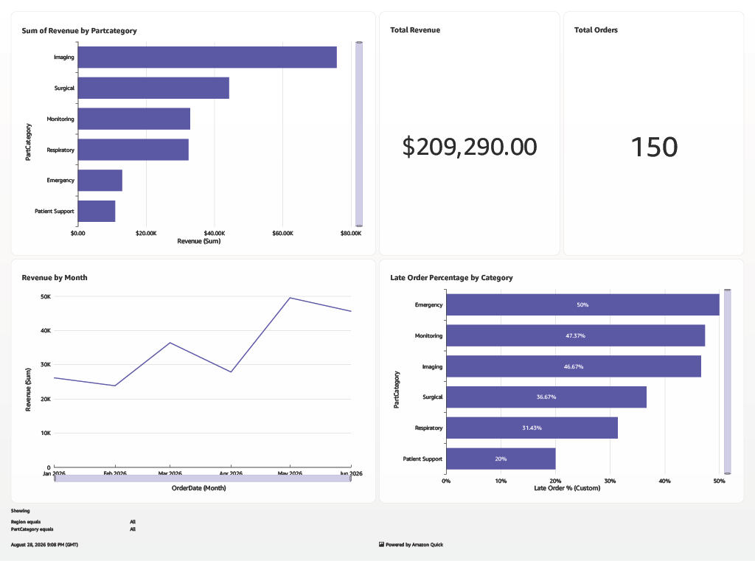

Business Recommendations
Investigate whether late orders in Emergency, Monitoring, and Imaging are concentrated among specific manufacturers, customers, or rush orders. Because category-level percentages may be affected by different sample sizes, future analysis should also compare total order volume and supplier-level performance before recommending operational changes.

Limitations
Revenue does not account for costs or margins, and shipping performance is measured only against expected shipping days contained in the dataset.

Conclusion
The analysis identified meaningful differences in revenue contribution and shipping performance across product categories. Emergency, Monitoring, and Imaging showed comparatively high late-order rates.

